*PIZZA SALES REPORT*

**Problem Statement**

*KPI Requirements:*

1. **Total Sales –** The sum of the total price of all pizza orders.
2. **Average Order Value –** The average amount spent per order, calculated by dividing the total sales by the total number of orders.
3. **Total Pizzas Sold –** The sum of quantities of all pizzas sold.
4. **Total Orders –** The total number of orders placed.
5. **Average Pizzas Per Order –** The average number of pizzas sold per order, calculated by dividing the total number of pizzas sold by the total number of orders.

*Charts Requirements:*

1. **Daily trend for total orders –** Create a bar chart that displays the daily trend of total orders over a specific time period. This chart will help us identify any patterns or fluctuations in order volumes on a daily basis.
2. **Hourly trend for Total Orders –** Create a line chart that illustrates the hourly trend of total orders throughout the day. This chart will allow us to identify peak hours or periods of high order activity.
3. **Percentage of Sales by Pizza Category –** Create a pie chart that shows the distribution of sales across different pizza categories. This chart will provide insights into the popularity of various pizza categories and their contribution to overall sales.
4. **Percentage of Sales by Pizza Size –** Generate a pie chart that represents the percentage of sales attribute to different pizza sizes. This chart will help us understand customer preferences for pizza sizes and their impact on sales.
5. **Total Pizzas Sold by Pizza Category –** Create a funnel chart that presents the total number of pizzas sold for each pizza category. This chart will allow us to compare the sales performance of different pizza categories.
6. **Top 5 Best Sellers by Total Pizzas Sold –** Create a bar chart highlighting the top 5 best-selling pizzas based on the total number of pizzas sold. This chart will help us identify the most popular pizza options.
7. **Bottom 5 Worst Sellers by Total Pizzas Sold –** Create a bar chart showcasing the bottom 5 worst-selling pizzas based on the total number of pizzas sold. This chart will enable us to identify underperforming or less popular pizza options.

*KPI Requirements:*

1. **Total Sales**

Query -

SELECT SUM(total_price) total_sales

FROM pizza_sales;

Result –



1. **Average Order Value**

Query –

SELECT SUM(total_price) total_sales,

COUNT(DISTINCT order_id) total_order,

SUM(total_price)/COUNT(DISTINCT order_id) AS average_order

FROM pizza_sales;

Result –



1. **Total Pizzas Sold**

Query –

SELECT SUM(quantity) total_pizza_sold

FROM pizza_sales;

Result –



1. **Total Orders**

Query –

SELECT COUNT(DISTINCT order_id) total_orders

FROM pizza_sales;

Result –



1. **Average Pizzas per Oder**

Query –

SELECT CAST(CAST(SUM(quantity) AS DECIMAL(10, 2)) /

CAST(COUNT(DISTINCT order_id) AS DECIMAL(10, 2)) AS DECIMAL(10, 2)) average_pizza_sold

FROM pizza_sales;

Result –



*Charts Requirements:*

1. **Daily trend for total orders**

Query –

SELECT DATENAME(DW, order_date) order_day,

COUNT(DISTINCT order_id) total_orders

FROM pizza_sales

GROUP BY DATENAME(DW, order_date);

Result –

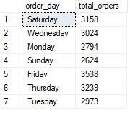

1. **Hourly trend for total orders**

Query –

SELECT DATEPART(HOUR, order_time) order_hours,

COUNT(DISTINCT order_id) total_orders

FROM pizza_sales

GROUP BY DATEPART(HOUR, order_time)

ORDER BY DATEPART(HOUR, order_time);

Result –

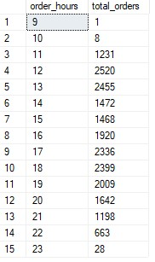

1. **Percentage of sales by pizza category**

Query –

SELECT pizza_category,

SUM(total_price) * 100 /

(SELECT SUM(total_price)

FROM pizza_sales) "sales(%)"

FROM pizza_sales

GROUP BY pizza_category;

Result –

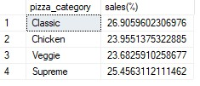

1. **Percentage of sales by pizza size**

Query –

SELECT pizza_size,

CAST(SUM(total_price) AS DECIMAL (10, 2)) sales,

CAST(SUM(total_price) * 100 /

(SELECT SUM(total_price)

FROM pizza_sales) AS DECIMAL (10, 2)) "sales(%)"

FROM pizza_sales

GROUP BY pizza_size

ORDER BY "sales(%)" DESC;

Result –

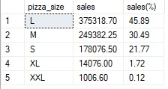

1. **Total pizzas sold by pizza category**

Query –

SELECT pizza_category, SUM(quantity) sell

FROM pizza_sales

GROUP BY pizza_category;

Result –

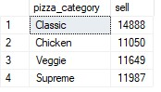

1. **Top 5 bestseller**

Query –

SELECT TOP 5 pizza_name, SUM(quantity) orders

FROM pizza_sales

GROUP BY pizza_name

ORDER BY SUM(quantity) DESC;

Result –

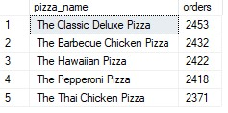

1. **Bottom 5 worstseller**

Query –

SELECT TOP 5 pizza_name, SUM(quantity) orders

FROM pizza_sales

GROUP BY pizza_name

ORDER BY SUM(quantity);

Result –

